Software Requirements Specification
for
Fooder Project

Prepared by: FOD Project Management Solutions, Inc.
Issue Date: November 11 2019

Version <1.0>

Contents
Contents ii
Revisions ii
1 Introduction 1
1.1 Document Purpose 1
1.2 Product Scope 1
1.3 Definitions, Acronyms and Abbreviations 1
1.4 Document Conventions 1
2 Overall Description 2
2.1 Product Overview 2
2.2 Assumptions and Constraints 2
3 Specific Requirements 3
3.1 External/Internal Interfaces 3
3.2 Functional Requirements 3
3.3 Use Case Model 4
4 Other Non-functional Requirements 8
4.1 Performance Requirements 8
4.2 Software Quality Attributes 8

Revisions
Version | Primary Author(s) | Description of Version | Date Completed
1.0 | Simon Fu | Completed Version of SRS | 11/10/19
1.1 | Simon Fu | Modified Version of SRS | 11/24/19

Introduction

Document Purpose
To develop a fully functional and user interactive application named Fooder, that will allow users to easily identify and track their nutritional intake in a meal by taking a picture. A machine-learning algorithm will be used to analyze the image and calculate a result.

Product Scope
In this project we will be developing a cross platform mobile application, allowing the user to take pictures of their food and automatically calculates the caloric and nutritional information of that picture with high accuracy. In the picture no external references are required. The computational time should be reasonable. It should be available 24/7. The platform should utilize Amazon web services; we store the pictures for research only. The final project must be delivered on budged and on time. The project is only in a mobile version, not a website. The ownership of the end product belongs to Digital Health Inc., the people who is evolved in the project own any part of the project. We don’t ask for personal information. All personal during the development of the project should not disclose information, except within the company.

Definitions, Acronyms and Abbreviations
AI – Artificial Intelligence

MB – Megabyte(s)

Document Conventions
In general this document follows the IEEE formatting requirements. Use Arial font size 11, or 12 throughout the document for text, and using italics for comments. Document text will be single-spaced and maintain the 1” margins found in this template.

Overall Description

Product Overview
The product offers an automated and enhanced method of tracking nutritional information in a meal. It allows for a more convenient and affordable method for logging food intake. This product can be compared to current existing applications that require manual measurements and inputs of food. Manual food logging applications require users to measure each individual ingredient, which results in a very time-consuming process. This decreases the ease of use for food logging, and would be particularly more difficult for beginners.

Assumptions and Constraints
This project is based on the following assumptions
- All project team members will be available during the project time frame.
- Funding is available once project is started.
- Project has executive-level support and backing.
- Project team will successfully manage to produce deliverables within scope, budget, and project schedule.
- Initial role of team members are not fixated throughout the project time frame.
- The Project Manager from the same company is not being assigned to two projects.
- The user allowed permissions to access built-in camera services.
- Images taken have all ingredients in view.

The app must achieve high accuracy in both food identification and calorie calculation. It has to be easy to use and pleasant. Moreover, the app must detect each food ingredient that is visually detectable. It must also use auto-calibration techniques, it should not use external objects in the image. Furthermore, the app must be highly scalable and use Amazon Cloud. It must also use AI for food detection. The AI training should be incremental and no re-train itself when every new picture is uploaded. The app should run on both Android and iOS. The image detection algorithm will reach a specific accuracy percentage with its initial dataset. However, as more users use the application it will learn from new images taken from users. The detection algorithm accuracy may fluctuate proportionally with the quality of the image provided.

Specific Requirements

External/Internal Interfaces

User Interfaces
A first-time user of the mobile application should receive a prompt that requests permission to access camera and file system services on their mobile device. If a user does not grant permission, the user will not be able to take or upload photos.

If the user is not a first-time user, he/she will be presented with a home screen. The user will be able to view a screen that summarizes their nutritional intake as well as view their snapshot history. In the home screen, the user will have two navigation options to either access the camera or the upload photo interface. The camera screen will look similar to a camera application and it will allow the user to take a picture of their food that will be used to calculate nutritional values. The upload photo screen will provide the user with a list of photos they can upload taken from their local storage, and is accessible in the photo-taking tab.

The user will be able to view the history of pictures analyzed in the past through the history navigation tab. Users will be presented with a interactive calendar where lists of past photos and their information are shown according to the date selected.

Hardware Interfaces
Since the mobile application does not have any designated hardware, it does not have any hardware interfaces.

Software Interfaces
The mobile application will communicate with and Amazon Cloud server to store its data.

Functional Requirements
3.2.1 The system shall run on both Android and iOS.
3.2.2 The system should use artificial intelligence for food detection.
3.2.3 The system must use Amazon Cloud to store its data.
3.2.4 The system shall detect each food ingredient that is visually detectable.
3.2.5 The system shall calculate the weight of each detected ingredient.
3.2.6 The system shall measure the actual dimensions of the food image taken by the user.
3.2.7 The system shall use auto-calibration techniques for images uploaded.
3.2.8 The system shall allow the user to upload food images stored from their mobile device.
3.2.9 The system shall allow the user to edit the food image to be uploaded.
3.2.10 The system shall allow the user to visualize the analysed food information.
3.2.11 The system shall allow the user to take a photo of the food.
3.2.12 The system shall allow the user to view previously uploaded photos.
3.2.13 The system shall require the user to have an Internet connected in order to upload or take photos.
3.2.14 The system shall allow the user to upload multiple photos at a time.

Use Case Diagrams

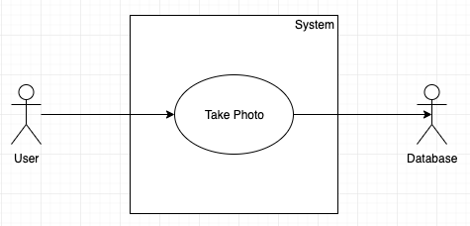
Use Case #1 (Take Photo – U1)
Purpose – To show the flow of events when a user takes a photo to be analyzed
Requirements Traceability – 3.2.1, 3.2.2, 3.2.3, 3.2.4, 3.2.5, 3.2.6, 3.2.7, 3.2.9, 3.2.10, 3.2.11, 3.2.13
Priority - High
Preconditions – The user has given the application camera service permissions and is connected to the Internet
Post conditions – The photo will be analyzed, stored, and the user views the information calculated
Actors – Human User
Flow of Events
  - Basic and Alternative Flows
    - User opens the mobile application
    - User allows camera and file permissions, and is connected to the internet
      - User did not allow permissions, or is not connected to the internet
    - User selects take photo navigation tab
    - User takes a photo
    - User confirms the photo
      - User edits, then confirms the photo
    - Photo is analyzed
    - Information is stored the Cloud and is displayed to the user.

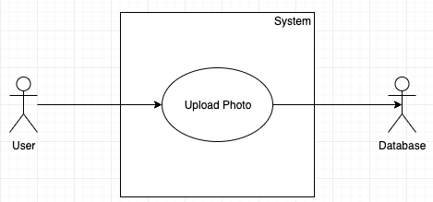
Use Case #2 (Upload Photo – U2)

Purpose - To show the flow of events when a user uploads a photo to be analyzed
Requirements Traceability – 3.2.1, 3.2.2, 3.2.3, 3.2.4, 3.2.5, 3.2.6, 3.2.7, 3.2.8, 3.2.9, 3.2.10, 3.2.13, 3.2.14
Priority - High
Preconditions - The user has given the application file system permissions and is connected to the Internet
Post conditions – The photo will be analyzed, stored, and the user views the information calculated
Actors – Human User
Flow of Events
  - Basic and Alternative Flow
    - User opens the mobile application
    - User allows camera and file permissions, and is connected to the internet
      - User did not allow permissions, or is not connected to the internet
    - User chooses to up one or multiple photos
    - User confirms the photo
      - User edits, then confirms the photo
    - Photo is analyzed
    - Information is stored the Cloud and is displayed to the user.

Use Case #3 (View Photo History– U3)
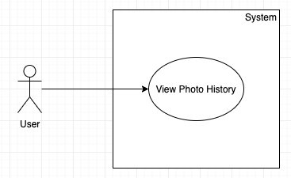
Purpose - To show the flow of events when a user views their photo analysis history
Requirements Traceability – 3.2.10, 3.2.12
Priority - Medium
Preconditions – The user is connected to the Internet
Post conditions – The list of photos that were analyzed are displayed to the user
Actors – Human User
Flow of Events
  - Basic and Alternative Flow
    - User opens the mobile application
    - User is connected to the internet
      - User is not connected to the internet
    - User chooses history navigation tab
    - System displayed photo history to the user

Other Non-functional Requirements

Performance Requirements
4.1.1 The software’s accuracy must be at least 94%.
4.1.2 The software’s transition time from a black screen to a functional interface should take less than 1 second.
4.1.3 The processing time of the image should be less than 3 seconds.

Software Quality Attributes
4.2.1 The software must allow photos to be uploaded with the extension .jpg and .png
4.2.2 The software shall have a maximum file upload size of 100 MB.
4.2.3 The software must allow photos with resolutions up to 4K to be uploaded.
4.2.4 The system should achieve at least 99.99% availability.
4.2.5 The system shall be able to handle a growing amount of work by adding resources to the system.
4.2.6 Upon the completion of the tutorial, the user shall be able to use up to 85% of functionality.

